**Geometry Lessons**

**Jared Anderson**

Comfrey High School

[janderson@comfrey.mntm.org](mailto:janderson@comfrey.mntm.org)

**James Bettin**

Clearbrook-Gonvick High School

[jbettin@clearbrook-gonvick.k12.mn.us](mailto:jbettin@clearbrook-gonvick.k12.mn.us)

**Troy Faulkner**

Byron High School

[troy.faulkner@byron.k12.mn.us](mailto:troy.faulkner@byron.k12.mn.us)

**Grades: 7 - 12**

**Executive Summary**

**Sandwich Shoppe (Triangle Congruence and Pythagorean Theorem) (Days 1-7)**

**MN Math Standard 9.3.2.5** Use technology tools to examine theorems, make and test conjectures, perform constructions and develop mathematical reasoning skills in multi-step problems. The tools may include compass and straightedge, dynamic geometry software, design software or Internet applets. (Sandwich Shoppe)

**Lessons/Days:**

**Day 1**: Introduction to the Sandwich Shoppe, Compass and Straightedge Practice, Pre-test

**Day 2**: Side lengths needed to form a triangle

**Day 3**: Have students draw obtuse, acute, and right triangle, measure side and help them to discover how a2 + b2 < = > c2 for each type of triangle

**Day 4**: Explore if SSS, AAA, and SAS form one triangle

**Day 5**: Explore if ASA, AAS, and SSA form one triangle

**Day 6**: In class practice of stating why two given triangles are congruent

**Day 7**: Review ways to prove triangles congruent, play a Kahoot game on reviewing these topics in class together, post-test

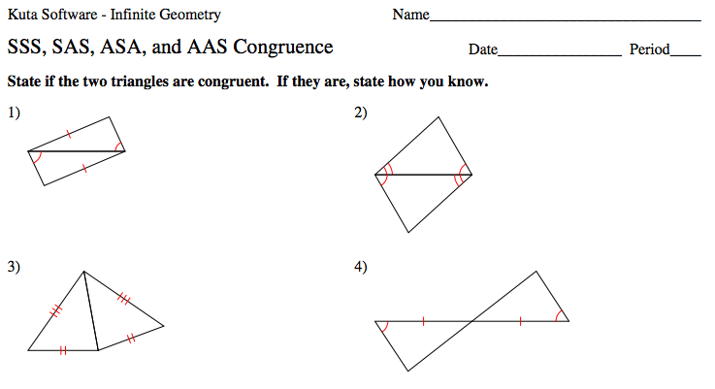**MCA Sample Question(s):**

**Similar 3-D Shapes (Side Lengths, Surface Area, and Volume of similar 3-D Shapes) (Days 8-14)**

**MN Math Standard 9.3.1.4** Understand and apply the fact that the effect of a scale factor k on length, area and volume is to multiply each by k, k2 and k3, respectively. (Scale Project)

**Lessons/Days:**

**Day 1**: Choose an object to “Scale”, Measure, plan how to build a “larger” version of object (new dimensions and material), and Pre-test

**Day 2**: Build Day

**Day 3**: Build Day

**Day 4**: Find side lengths, surface area and volume of new “larger” object and the relationships of those

**Day 5**: Work day for students to develop their presentation to share with class

**Day 6**: Presentation Day

**Day 7**: Presentation Day and post-test

**MCA Sample Question(s):**

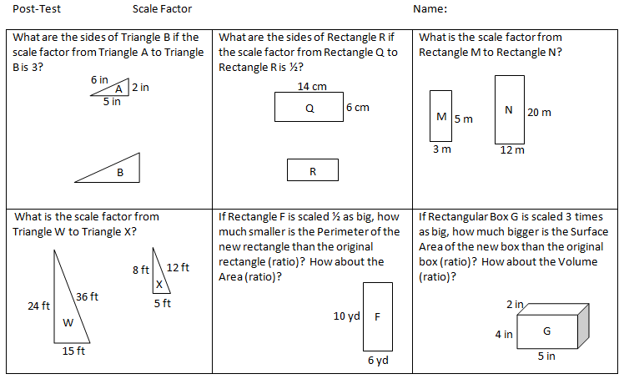

**Circles (Discovering Pi, Circumference and Area of Circles) (Days 15-20)**

**MN Math Standard 7.3.1.1** Demonstrate an understanding of the proportional relationship between the diameter and circumference of a circle and that the unit rate (constant of proportionality) is pi. Calculate the circumference and area of circles and sectors of circles to solve problems in various contexts. (Circle Unit)

**Lessons/Days:**

**Day 1**: Concept Attainment: Diameter, Circle, Center, Radius, Circumference, in class Kahoot on this material, and Pre-test

**Day 2**: Approximate π using paper strips exploration

**Day 3**: Measure different circles (circumference and diameter) to develop the approximation of π

**Day 4**: Approximate the area of a circle using the grid method and develop formula for area of a circle by cutting smaller and smaller sectors to form one large rectangle

**Day 5**: Use real life circles to find area, and in class practice of worksheet

**Day 6**: Kahoot practice, in class practice and post-test

**MCA Sample Question(s):**

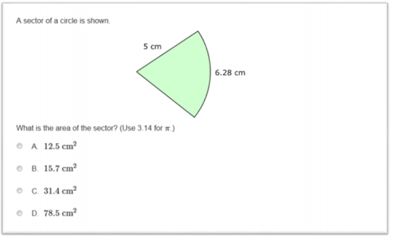

**Table of Contents**

Page 1 Title Page

Page 2 Executive Summary

Page 2 Executive Summary: Sandwich Shoppe

Page 4 Executive Summary: Scale Project

Page 6 Executive Summary: Circles Unit

Page 8 Table of Contents

Page 9 Lessons

Page 9 Lessons: Sandwich Shoppe

Page 15 Lessons: Scale Project

Page 19 Lessons: Circles Unit

**Lessons**:

**Sandwich Shoppe** (Math 6500 Geometry in the Classroom for Elementary and Middle Level Teachers)

**Launch:** Troy and Jared decided teaching isn’t for them. They both have a unique interest in cooking, so they decided to go into a sandwich business together. The problem is that these two like crunching numbers so they are busy in the office. They have hired you to create the different sandwiches that they will serve. Before they turn you lose they want to know that you can create each of the sandwiches on the menu. You need to create the exact sandwich and show it to them for approval. If you screw this up, you will be out of luck.

**Explore:** Students will use a compass, protractor, and straightedge and a PENCIL to create the different triangles that are described in the recipes. The recipes will provide examples of the four triangle congruences we wish to cover as well as examples of similar triangles and non-triangles.

**Share:** Students will share their finding with the class. I will emphasize the AAA Triangle as a “similar” example and allow multiple groups to show their triangle. This will highlight the key difference in similar and congruent. We can use the other sandwiches to show why everyone's sandwich is the same and ask why that is? I will also note that SSA could either make 0, 1, or 2 possible triangles depending on the given side lengths and angle.

**Summarize:** To gain experience with the tools, I will have students create basic images such as segments, angles, arcs and circles. This will be important for the use of compass and straightedge in the activity. Students should find one sandwich is not possible and one sandwich as similar but not congruent. The sandwich that is not possible will be an application of the possible side lengths of a triangle we discovered earlier in the unit. We achieve this conclusion by using hands on triangles and drawings to show what can make a triangle and what cannot. The remaining triangles will indicate ways we can later prove that triangles are congruent using two column proofs and flow proofs. The four triangle congruences this activity brings to our attention are SSS (Side-Side-Side), SAS (Side-Angle-Side), ASA (Angle-Side-Angle), and AAS (Angle-Angle-Side). These discoveries will lead to student led discussions on why these things work and how we are able to identify the difference between them.

**9.3.2.5** Use technology tools to examine theorems, make and test conjectures, perform constructions and develop mathematical reasoning skills in multi-step problems. The tools may include compass and straightedge, dynamic geometry software, design software or Internet applets.

**Day 1**: Introduce students to the Sandwich Shoppe story and take a pretest to see what they know already. Give students instructions and practice on using a compass, protractor, and straightedge to construct different shapes.

**Day 2**: Inform students that many customers will want sandwiches with different side lengths and that the sandwich workers must know if they can make those sandwiches or not. Divide students up into groups of three or four. Each group will be assigned multiple sets of side lengths that are supposed to make each triangle sandwich (Examples: 5cm, 6cm, and 7cm is one set and 5cm, 6cm, 12cm is another set). Each group should be assigned at least two sets that do make a triangle, one set that doesn’t make a triangle (with the short sides touching), and one set that doesn’t make a triangle (with the short sides missing each other). Groups will need to create sandwiches given the side lengths (if they can). Using the compass and straightedge, students will draw out the set of given lengths onto a piece of paper and cut out the triangle if one is made. If a triangle is not made, students should hold on to the piece of paper as evidence that the set used will not create a triangle. Groups will need to decide for each set of side lengths if they can make a triangle and if not, do the shorter sides touch or miss each other completely. After all groups have decided whether or not their sets create triangles, the teacher will compile all of the data in a table displayed in the front of the room (Google Spreadsheets or Excel). Students should discuss which sets did create triangles and why and come up with a “rule” to determine whether or not three given side lengths can create a triangle. The rule should be similar to “the two shorter sides must add up to be greater than the longest side.”

**Day 3**: Divide students into groups of three or four. Have each group of students draw at least one obtuse triangle, at least one acute triangle, and at least one right triangle. Each group should measure the three sides and report them to the teacher to be collected in the class table. When the teacher collects the data, they should be sure to add in extra columns of data to square each side length. The teacher should ask if the students see a connection between the side length numbers as they are (using addition, subtraction, multiplication, or division) OR if they see a connection between the squared numbers. Students should discuss which sets created right triangles, which sets created acute triangles, and which sets created obtuse triangles. Students should come up with a “rule” to determine whether or not three given side lengths will create an acute, right, or obtuse triangle. The rule should be similar to “If the two shorter sides squared add up to be: 1. Greater than the longest side squared, then the triangle is acute; 2. Less than the longest side squared, then the triangle is obtuse; 3. Equal to the longest side squared, then the triangle is right” OR how a2 + b2 < = > c2 for each type of triangle.

**Day 4**: Divide students into groups of three or four. Each group will be provided with at least two “recipes” (sets) of three side lengths (different sets but same throughout the class), three angles lengths (different sets but same throughout the class), and two side lengths and the angle between them (different sets but same throughout the class). A discussion should also be had about whether or not the angle given was included between the two given sides. If multiple groups are finishing before others they should be given another set of three angles that is the same as the other groups’. Once all groups have finished constructing their triangular “sandwiches,” groups should be paired up to see if their triangles are the same as other groups’ triangles. Then the groups should share their findings with the entire class to see what recipes consistently produce the same exact triangle and which ones do not. The teacher should discuss the meaning of “congruence” and how SSS and SAS produce “congruent” triangles. The teacher should also discuss the meaning of “similarity” and how AAA produces “similar” triangles.

**Day 5**: Divide students into groups of three or four. Each group will be provided with at least two “recipes” (sets) of two angles and the side length between them (different sets but same throughout the class), two angles and the side length NOT between them (different sets but same throughout the class), and two side lengths and the angle NOT between them (different sets but same throughout the class). A discussion should also be had about whether or not the side given was included between the two given angles. If multiple groups are finishing before others they should be given another set of two sides and a non-included angle. Once all groups have finished constructing their triangular “sandwiches,” groups should be paired up to see if their triangles are the same as other groups. Then the groups should share their findings with the entire class to see what recipes consistently produce the same exact triangle and which ones do not. The teacher should recall the meaning of “congruence” and how ASA and AAS produce “congruent” triangles. The teacher should also discuss the meaning of “non-congruence” and how SSA produces “non-congruent” triangles.

**Day 6**: The students will work on a worksheet practicing identifying when two given triangles are congruent and the congruence “reason” (similar to the post-test).

**Day 7**: The teacher will review ways to prove triangles congruent and go over the review worksheet. Students will play a Kahoot game on reviewing these topics in class together and once the Kahoot is over the students will take a post-test.

Exit Slip for Day 2 Name:__________________________

Choose three of these to answer. Do the given side lengths make a triangle? Why or why not?

|  |  |  |
| --- | --- | --- |
| Easy | Medium | Challenge |
| 1. 5cm , 7cm , 9cm | 3. 23in , 145in , 168in | 5. 2ft , 30in , 2yd |
| 2. 4in , 7in , 11in | 4. 67m , 17m , 85m | 6. 1m , 97cm , 33mm |

Exit Slip for Day 2 Name:__________________________

Choose three of these to answer. Do the given side lengths make a triangle? Why or why not?

|  |  |  |
| --- | --- | --- |
| Easy | Medium | Challenge |
| 1. 5cm , 7cm , 9cm | 3. 23in , 145in , 168in | 5. 2ft , 30in , 2yd |
| 2. 4in , 7in , 11in | 4. 67m , 17m , 85m | 6. 1m , 97cm , 33mm |



<https://cdn.kutasoftware.com/Worksheets/Geo/4-SSS%20SAS%20ASA%20and%20AAS%20Congruence.pdf>

**Similar 3-D Shapes (Side Lengths, Surface Area, and Volume of Similar 3-D Shapes)**

(Jared Anderson -Jr. High Project Idea)

**Launch:** 3M’s “sister” company 3D is looking for up and coming designers to create some of its products. Instead of having to create all new products, all you need to do is make a bigger OR smaller version of something you already have. 3D will need to know the specifications of the original object that you were working from as well the specifications of the new product so that they can begin production. We will create and use models of our new products to discover how much we need of the materials to build the new product as opposed to the original.

**Explore:** After the launch, students will take a pretest to see what they already know about scale factor. Then, students will work individually (or in pairs) to choose an object that they will scale up or scale down. The teacher should direct “high flyers” to objects like spheres and cylinders (more difficult for surface area and volume), and “low flyers” to objects like rectangular boxes (less difficult for surface area and volume).

After students choose their objects, they will also choose their own scale factor. The teacher should direct “high flyers” to non-integer scale factors like ⅔ or 1.8 (more difficult numbers for squaring and cubing), and “low flyers” to scale factors like ¼, ½, 2, or 3 (less difficult numbers for squaring and cubing).

Once students have their object and scale factor chosen, they will need to begin measuring dimensions of their objects. They should have at least 10 different measurements (side lengths, diameters, logo sizes, etc). Students will then calculate the new dimensions of the product using their scale factor.

After students have taken all of their measurements, they will need to create a plan for how they will construct their model and what materials they will need. This plan should spell out how much material they need (cardboard, cardstock, glue, tape, paint, markers, etc) and show how they will piece everything together.

Students will spend the next two days building their new product. This can be done in a separate location like the art room if it works better than in the normal classroom.

Once the new product is finished, students will need to find the surface area and volume of both the original object and the new product. The measurements they used to determine these and the work they did to determine surface area and volume should be shown and discussed in their final presentation. Students should also conjecture on a rule linking their scale factor to the ratio of the original to new surface areas AND the original to new volumes.

**Share:** After constructing the new product, calculating surface area and volume, and coming up with rules for connecting scale factor, surface area, and volume, students will develop a presentation to share their work with the class. This should be done on PowerPoint, Google Presentation, or some other digital presentation form that can be shared with the teacher. Students will present their product and their work to the class. The class will discuss the connection between scale factor, surface area, and volume when working with 3-D objects or 2-D shapes.

**Summarize:** As students are sharing their presentations, they should be thinking about the connection between scale factor on a single dimension (length), two dimensions (surface area), and three dimensions (volume). The teacher should be recording each product, its scale factor, ratio of original surface area to new, and the ratio of original volume to new. At the end of all of the presentations, the students should be able to see a list of all of the products and these ratios. If the student discussion has not lead to it already, the teacher should bring up the fact that since scale factor only affects one dimension, then both dimensions will be affected separately when dealing with a 2-D figure and therefore the scale factor must be multiplied by itself when finding area (scale factor k becoming AREA factor k2). Similarly, the scale factor must multiply by itself again for volume since there are three dimensions (scale factor k becoming VOLUME factor k3). This is also where the idea of “units” of length, “units2” of area, and “units3” of volume come from.

**9.3.1.4** Understand and apply the fact that the effect of a scale factor k on length, area and volume is to multiply each by k, k2 and k3, respectively.

**Day 1**: Launch and Pretest. Students choose an object to “Scale” and a scale factor to scale by. Then they will measure dimensions of the original object and plan how to build a “larger” version of object (new dimensions and materials needed).

**Day 2**: Build Day; Students spend the day constructing their new product. This might be done in a separate room like the art room if it works to do so.

**Day 3**: Build Day; same as Day 2.

**Day 4**: As students finish building their product, they will need to find side lengths, surface area and volume of both the original object and the new “larger” object and the relationships of those.

**Day 5**: Work day for students to develop their presentation to share with class reminding students to show their work on finding surface area and volume of their objects.

**Day 6**: Students begin presenting their work and findings to the class.

**Day 7**: Students will finish presenting their work today. Afterwards, they will discuss the connection between scale factor, AREA “factor”, and VOLUME “factor”, as well as take a short post-test to see what they learned.

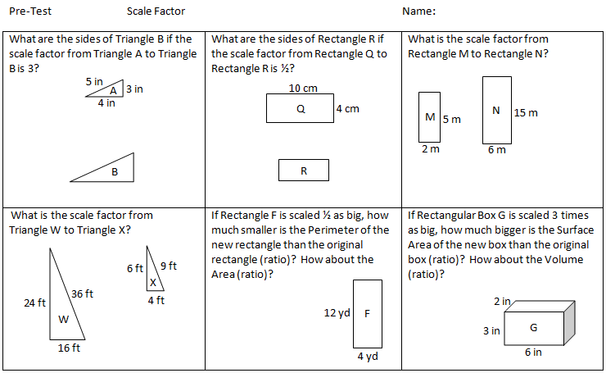



**Circles (Discovering π (pi), Circumference and Area of Circles)**

(James Bettin, Jared Anderson: Lesson used at Win-E-Mac Public Schools-Jessica Strom’s Classroom (Math Methods).)

**Launch:** Many people believe that Egyptians were responsible for many mathematical findings, but little did they know they were living in “Da Nile”. They need your help in proving there is some sort of relationship between the circumference and diameter of a circle.

**Explore:** Students will use paper strip that are a diameter in length to measure the circumference. They will discover that the circumference is a little more than three diameters in total. Students will use circular objects and measuring tools such as string and rulers to accurately measure key information on their object. The class will create a chart with object name, circumference, diameter, circumference/diameter (Excel). Students will measure multiple objects of different size to compare results with the rest of the class. Once we have found the approximation for π, we will use different circle representations to create a rectangular model. This model will correlate area of a circle with area of a rectangle, a much more familiar topic. I will have the students use a circle placed on a grid to use any method they choose for approximating area of a circle. We can then apply our newfound area formula to apply to real life circle representations. They extension of this activity will be to find area of sections of circles (sectors).

**Share:** Students will share the results of their measurements. We can use this large number of measurements to exclude any outliers and then as a class create the approximation for π. We can use class discussions to ask why they believe this is what it is or why it cannot be another way. Once the students have become familiar with the concept of π being used to find the circumference, they will shift towards using the circumference to find the area of the circle. From here they will also explore finding “fractions” of the area (sectors).

**Summarize:** The overall goal for the circle unit is to discover what π is as well as connect previous knowledge of area of a rectangle and discover how to find area of a circle. Vocabulary will become very important in this process to help distinguish between the different parts of an object. Once the students have discovered what π is and its relationship, we can apply this idea at a more abstract level. We will use a concrete example of approximating area of a circle to connect the actual value when using an abstract formula. Being able to connect a concrete example with an abstract idea will help the students connect those missing links.

**7.3.1.1** Demonstrate an understanding of the proportional relationship between the diameter and circumference of a circle and that the unit rate (constant of proportionality) is pi. Calculate the circumference and area of circles and sectors of circles to solve problems in various contexts.

**Day 1**: Pre-test will be given that resembles the post-test, with only slight changes in values. This will allow us to gauge students’ prior knowledge. We will use concept attainment to classify or define terms used in this activity. This idea is associating an “alien” word with examples that lead student to forming their own definition, coupled with an exact definition if needed. We will use a Kahoot for practice once the definitions have been agreed upon by the entire class. Terms to be defined are: circle, radius, chord, diameter, circumference, arc, and sector.

**Day 2**: Students will bring in circular objects that they can find (coffee can, coin, ice cream pail…). The will use these objects and measure the diameter. With the diameter measurement, we will create paper strips as measuring devices marking off multiples of the diameter onto the paper strip. Then they will use this to measure the circumference of the object. Our intended discovery is that the circumference is greater than 3 diameters. This will help us lay a foundation for discovering π.

**Day 3**: With the different circular objects, students will create a table with circumference and diameter of as many objects as they can measure in the allotted time. As a class we will compile data and then create the relationship of circumference/diameter as π.

**Day 4**: Students will get a handout that has a circle placed on a grid. The will use any estimation method they choose to find the approximate area of the circle. The class will show all the different ways that has been done. We will then cut out that circle into equal sectors. Each time we cut will form a rectangular shape until they are convinced that the rectangle will be formed. We can label the pieces in the new rectangle as pieces of the original circle to make the connection. This will in turn prove the area of a circle formula.

**Day 5**: Use the proven formula to apply to real life circles in a semi-concrete/abstract way. Check for understanding.

**Day 6**: We will use a Kahoot to review what π is, how it is used, as well as examples to find the area of a circle. These will be presented in a similar way to how the pre and post tests have been given. A post test will be given the following class period.

